GOVERNMENT FIRST GRADE COLLEGE
Krishnarajapura, Bengaluru 560 036

BENGALURU NORTH UNIVERSITY
TAMAKA POST, KOLAR - 563 101



A Project Report On

" SMART CAR PARKING SYSTEM "
Submitted in partial fulfilment of the requirement for the award of the
Degree Bachelor of Science (ECs)

Submitted By

AKASH.R : U19GZ23S0277

Under the guidance of

Mr. PARTHASARATHI N

Assistant Professor of Electronics
GFGC, Krishnarajapura, Bengaluru — 560 036.
2025 – 2026

DEPARTMENT OF ELECTRONICS
Krishnarajapura — 560 036

CERTIFICATE

This is to certify that the project report of “SMART CAR PARKING SYSTEM”
Using Infrared Sensor (IR Sensor) is the work done by

AKASH.R : U19GZ23S0277

Under the guidance and supervision of Mr. PARTHASARATHI N, Assistant Professor of Electronics, GFGC, Krishnarajapura, Bengaluru — 36, during the VI semester for partial fulfilling the requirement of Project of Bachelor of Science (ECs) at Government First Grade College, Krishnarajapura, Bangalore-560 036.

Mr. PARTHASARATHI N
Guide

Mrs. GIRIJA MANGALGATTI
HOD
Department of Electronics
GFGC, Krishnarajapura

DECLARATION

We hereby declare that this project name “SMART CAR PARKING SYSTEM” Using Infrared Sensor (IR Sensor) is an original and Bonafede work carried out by me and my team under the guidance of Mr. Parthasarathi N, Assistant Professors of Electronics, GFGC, Krishnarajapura, Bengaluru — 36.

I further declare that this mini project report is not submitted to any other
University/College for the award of any degree or diploma.

Signature of the student with date

AKASH.R : U19GZ23S0277

Place: Krishnarajapura, Bengaluru.

ACKNOWLEDGEMENT

To list who all have helped me is difficult because they are so numerous, and the depth is so enormous.
I would like to express my heartfelt gratitude to our guide Mr. PARTHASARATHI.N for their guidance and encouragement.
I take this opportunity to thank GOVERNMENT FIRST GRADE COLLEGE Bangalore for giving me a chance to do this project.

I am extremely grateful to the Head of the Department Mrs. GIRIJA MANGALGATTI and all the faculty of Bachelor of Computer science[ECs]
I take this opportunity to thank our Principal, Dr. NALINI.R for her moral support and guidance.
I am deeply indebted to my family members for their unconditional love, patience, and support. Their constant encouragement and blessings have always been a source of strength and inspiration.
Lastly, I would like to thank each person who directly or indirectly helped me in the completion of the project especially my Parents, Bachelor of Computer Science (ECs) Admin and college teaching staff, who supported me throughout my project.

AKASH.R : U19GZ23S0277

CONTENTS

Sl.No | Contents | Page no
1 | Introduction | 6
2. | Block Diagram | 7
3. | Working Mechanism & Required components | 8
4. | Details of components | 9
5 | Flow Chart | 21
6 | Circuit Diagram and Explanation | 23
7 | Code explanation and running | 24
8 | Advantages | 35
9 | Future Enhancement | 36
10 | Disadvantages | 38
11 | Conclusion | 40
12 | Reference links | 41

Introduction of Smart car parking system

using IR-sensor and Arduino

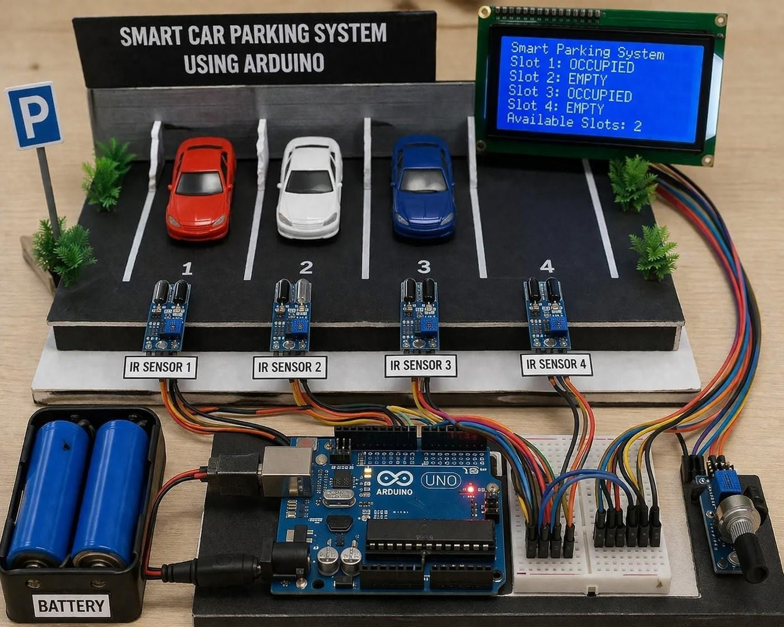

In today’s rapidly growing world, the number of vehicles is increasing at a very fast rate, especially in urban areas. This rise in vehicle population has created a major challenge in managing parking spaces efficiently. Traditional parking systems often lead to problems such as traffic congestion, time wastage, fuel consumption, and driver frustration due to the difficulty in finding available parking slots. Therefore, there is a strong need for an intelligent and automated parking management system.

The Smart Car Parking System using Arduino is an innovative solution designed to address these issues by automating the process of parking space monitoring and management. This system uses an Arduino Uno microcontroller as the central processing unit, along with IR (Infrared) sensors to detect the presence or absence of vehicles in each parking slot.
An LCD display is used to provide real-time information about the availability of parking spaces, making it easier for drivers to locate free slots quickly.

The working principle of this system is simple yet effective. Each parking slot is equipped with an IR sensor that continuously monitors whether a vehicle is present or not. When a car occupies a slot, the corresponding sensor detects it and sends a signal to the Arduino. The Arduino processes these signals and updates the status of each slot. This information is then displayed on the LCD screen, showing which slots are occupied and how many spaces are available. As a result, drivers can easily identify vacant slots without unnecessary searching.
One of the major advantages of this system is its ability to provide real-time monitoring of parking spaces. This not only reduces traffic congestion inside parking areas but also saves time and fuel for users. Moreover, the system is cost-effective, easy to implement, and suitable for small-scale applications such as colleges, offices, shopping complexes, and residential buildings.

Block diagram of smart car parking system:

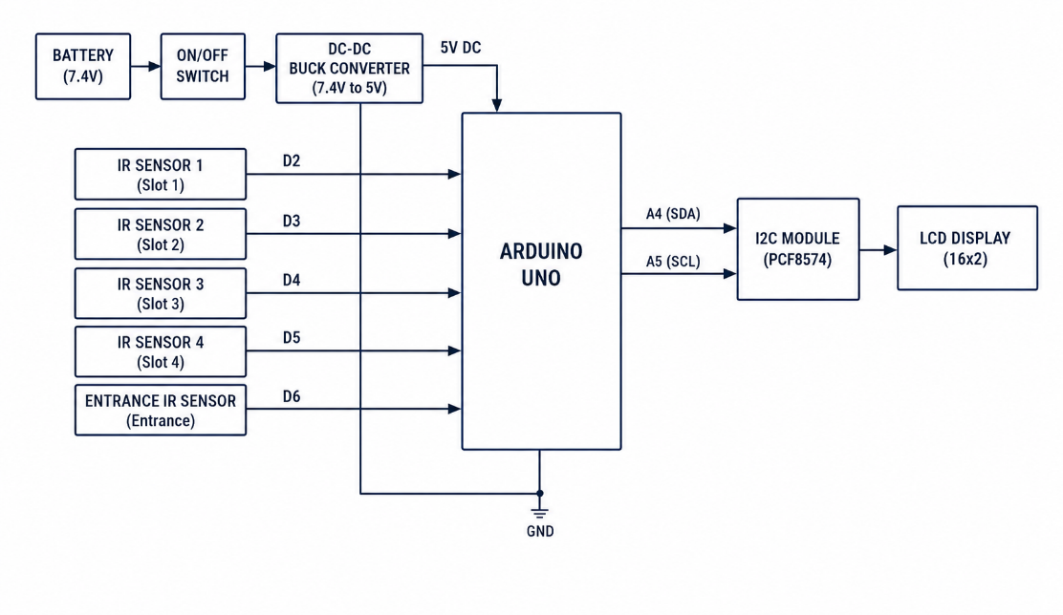

This block diagram representing a systematic flow of power and data, starting from the power supply, moving through sensors and the Arduino for processing, and ending at the display unit for output. The entire system operates continuously, updating the parking status in real time, making it an efficient and practical solution for modern parking management.

Working Mechanism

The Smart Car Parking System operates on the principle of automatic detection, processing, and display of parking slot availability using sensors and a microcontroller. The entire system works in a continuous loop to provide real-time updates.
When the system is powered ON through the battery, the voltage is regulated to a stable 5V using a DC-DC converter. Each parking slot is equipped with an IR sensor that continuously monitors the presence or absence of a vehicle. These sensors work by emitting infrared rays and detecting their reflection. When a car is present in a parking slot, the IR rays are reflected back to the sensor, generating a HIGH (1) signal. If no car is present, the rays are not reflected in the same way, and the sensor outputs a LOW (0) signal. This allows the system to distinguish between occupied and empty slots.
The Arduino UNO reads these digital signals from all the IR sensors through its input pins. It processes the received data by checking the status of each sensor individually. If a sensor outputs HIGH, the Arduino marks that particular slot as occupied. If the output is LOW, the slot is considered empty.
Once the processing is complete, the Arduino sends the updated information to the LCD display.This entire process is repeated continuously in a loop. As vehicles enter or leave the parking area, the IR sensors instantly detect the change, and the Arduino updates the information accordingly. This ensures that the system always provides real-time and accurate parking status.
In summary, the working mechanism involves three main stages: sensing (by IR sensors), processing (by Arduino), and displaying (by LCD). The system efficiently automates parking management by reducing manual effort, saving time, and improving the overall user experience.

Required components
  - Arduino UNO
  - Proximity IR Sensors
  - LCD Display(16x2)
  - Power supply or Cells
  - Connecting wires
  - Jumper wires

Description of the important component:
Arduino


Arduino is an open-source electronics platform based on easy-to-use hardware and software arduino board are able to read inputs - light on a sensor, a finger on a button, or a Twitter message - and turn it into an output - activating a motor, turning on an LED, publishing something online. You can tell your board what to do by sending a set of instructions to the microcontroller on the board. To do so you use the Arduino programming language(based on Wiring), and the Arduino Software (IDE), based on Processing
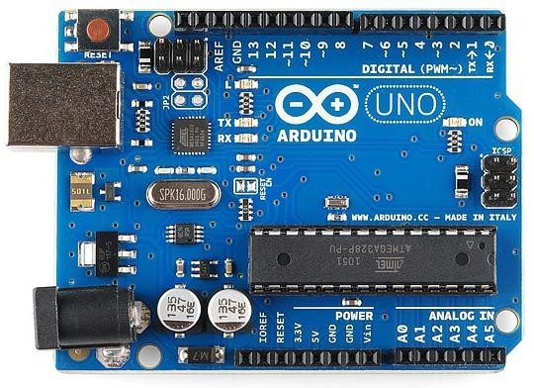

Arduino Uno Board
It designs and manufactures microcontroller kits and single-board interfaces for building the electronics projects. The Arduino were initially created to help the students with the non-technical background. The Arduino is used for various purposes, such as:
- Finger button
- Button for motor activation

- Light as a sensors
- LED button
- Designing
- The building of electronics devices

Arduino UNO is a microcontroller board based on the ATmega328P.It has 14 digital input/output pins, they are,
Reset button, AREF, TX and RX LED’S, Digital I/O pins, Power LED Indicator, ICSP pin, ATmega328 Microcontroller, Analog pins, Vin, GND, 5V, 3.3v, Reset, Power Button, Voltage Regulator, Crystal Oscillator, USB.
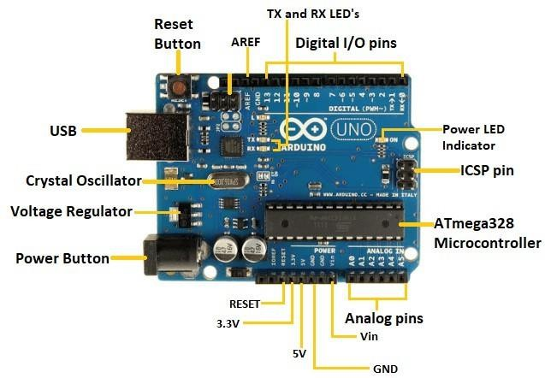

Reset button:- White or blue push button located on top of Arduino board, pressing it has same effect as disconnecting and reconnecting the power supply.
AREF:- To provide an external reference voltage for the analog to digital conversion of inputs to analog pins. AREF means Analogue REFerence
TX and RX LED’s:-TX and RX stands for Transmitting and Receiving pins of Arduino used for serial communication. TX and RX LED are connected to pin 0 and 1 thus whenever the Arduino send or receive data over serial pins, the LED connected to TX and RX blinks respectively.
Digital I/O pins:- The pins 4,6,8,9,10, and 12 are used as digital input or output for Arduino board. These pins are interface between Arduino board and computer or other devices.

ICSP pin :- ICSP stnands for In-Circuit Serial Programming. It is used to code and boot an Arduino from an external source.
ATmega328 Microcontroller:- Used in many projects and autonomous systems where a simple, low-powered, low cost, microcontroller is needed.
Analog pins:-It is used to read analog sensors. The pins A0 to A5 are used as an analog input and it is in the range of 0-5v.
Vin:- This pin can work as a voltage input for regulated external power supplies.
GND:- This pin is used to ground the Arduino board.
Power button:- Connect two points in circuit when you press them.
Voltage regular:- Allows you to use its coaxial power supply to 8 to 20 volts DC.
Crystal oscillator:-Delivers only required amount of voltage to the input of the Arduino board and controls the DC power supply utilized by the microcontroller and other devices.

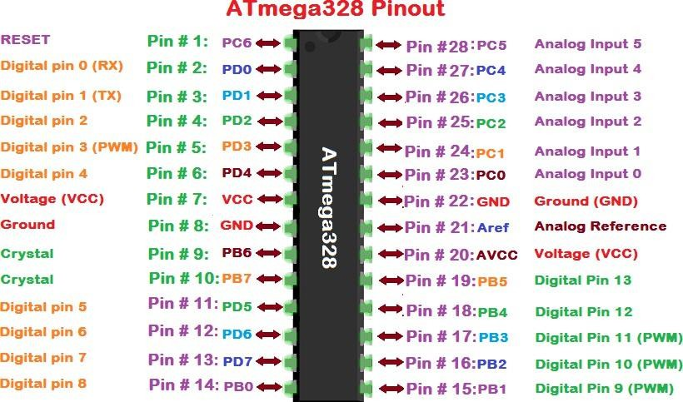
ATmega328 Microcontroller Pin Diagram

Technical Specification of Arduino
- Microcontroller: ATmega328P
- Operating Voltage: 5V
- Input Voltage (recommended): 7-12V
- Digital I/O Pins: 14 (of which 6 provide PWM output)
- Analog Input Pins: 6
- Flash Memory:32 KB (Program Memory)

- SRAM: 2 KB(Data Memory)
- EEPROM:1 KB (Non Volatile Memory)
- Clock Speed:16 MHz
- LED_BUILTIN: 13

Features of Arduino

It is open source:
The Arduino software and hardware are open source. In essence, this means users have access to the source code and can modify it to suit their needs.
- It is based on C++:
The Arduino programming language is based on C++, a widely used and well-known programming language.

It has a large library of pre-written code:
Arduino has a large library of pre-written code called the Arduino library. Basically, this simplifies common tasks and makes it easy to interact with sensors and other devices connected to the board.

It has a simple syntax:
The Arduino programming language has a simple syntax. Hence, it is easy to learn and understand, even for beginners.

It has cross-platform compatibility:
The Arduino software runs on Windows, macOS, and Linux. Thus, it is easy to develop and upload code to the board, regardless of the user’s operating system.

It has serial communication:
Arduino has a built-in serial communication feature that allows the board to communicate with a computer or other devices via USB.

It has built-in support for PWM:
Pulse width modulation (PWM) is a built-in feature of the Arduino boards that allows for the precise control of the amount of power delivered to a device, such as a motor or LED.

Advantages of Arduino
Arduino has been used for a long time in electronic projects and it has been the favorite board of beginners in the electronic world. Here are some advantages of Arduino due to which it is so popular.

Easy to Learn and Use
The Arduino programming language is based on C++, with a simple and straightforward syntax that is easy to pick up even for beginners.

Versatility
Arduino boards can be used in a wide variety of projects, such as robotics, home automation, and IoT applications.

Widely Supported
The Arduino community is large and active, with a wealth of resources and tutorials available to help users learn and troubleshoot.

Cost-Effective
Arduino boards and components are relatively inexpensive, making them accessible to hobbyists and students.

Open Source
The Arduino software and hardware are open source, which means that users have access to the source code and can modify it to suit their needs.

Cross Platform Support
Arduino is not limited to windows it is also available across multiple platforms like Linux and macOS. Most of the microcontrollers can only be programmed using windows but not in case with Arduino.

Tons of Libraries
Many Arduino libraries are available to control external sensors, module, and motors. Functionality of Arduino boards can be extended using these libraries provide the user free hand to play with hardware and manipulate data easily.

Inexpensive Hardware
Arduino boards are available at low cost. To start building our first program we just need an Arduino board as its development tool IDE is freely available. There is no need for any external hardware, multiple projects can be made using single Arduino boards which cut overall project cost by a great margin.

Active User Community:
Arduino is an open-source community with many online supports available on Arduino forum. Thanks to open-source nature of Arduino projects, as a lot of work on multiple topics has already been done. Multiple Arduino projects starting from fan controllers to smart homes have been designed already.

Disadvantages of Arduino
Arduino boards are not always the best choice, with so much to offer Arduino has some disadvantages too. Here is a brief description of a few shortcomings Arduino have.

Limited Memory and Processing Power
Arduino boards have limited memory and processing power compared to larger microcontroller boards or full-fledged computers. This can limit the complexity and size of projects built with Arduino.

Limited Support for Some Communication Protocols
Arduino boards have built-in support for some communication protocols, such as USB, Ethernet, and Wi-Fi, but lack support for other protocols like Zigbee, Z-wave, Thread, or LoRa.

Limited Real-Time Performance
Arduino boards are not designed for real-time applications that require a high degree of accuracy in timing and responsiveness.

PROXIMITY IR SENSOR:-

IR Sensor:

An infrared (IR) sensor is a type of electrical gadget that detects and measures infrared radiation in its surroundings. In the year 1800, an astronomer named William Herchel made an unintentional discovery of infrared radiation. He found that the temperature just beyond the red light was the highest when measuring the temperature of each hue of light (separated by a prism). Because the wavelength of IR is longer than that of visible light, it is invisible to the human eye (though it is still on the same electromagnetic spectrum).Infrared radiation is emitted by everything that emits heat (anything with a temperature over roughly five degrees Kelvin).

This IR Proximity Sensor is a multipurpose infrared sensor which can be used for obstacle sensing, color detection, fire detection, line sensing, etc and also as an encoder sensor. The sensor provides a digital output. The sensor outputs a logic one(+5V) at the digital output when an object is placed in front of the sensor and a logic zero(0V), when there is no object in front of the sensor. An onboard LED is used to indicate the presence of an object. This digital output can be directly connected to an Arduino or any other microcontroller to read the sensor output.
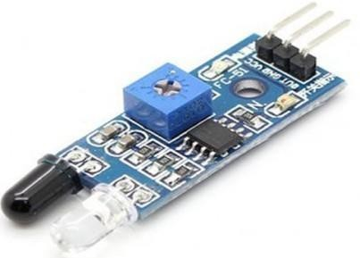
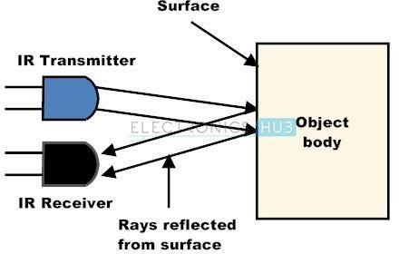
Obstacle Infrared Sensor

IR sensors are highly susceptible to ambient light and the IR sensor on this sensor module has to be properly covered to reduce effect of ambient light on the sensor. The sensor has operating range of around 10-20 cm. The IR sensor module includes five essential parts like IR Tx, Rx, Operational amplifier, trimmer pot (variable resistor) & output LED. The pin configuration of the IR sensor module is discussed below.
- VCC Pin is power supply input
- GND Pin is power supply ground
- OUT is an active-high o/p

The main specifications and features of the IR sensor module include the following.
- The operating voltage is 5VDC
- I/O pins – 3.3V & 5V
- Mounting hole
- The range is up to 20 centimeters
- The supply current is 20mA
- The range of sensing is adjustable
- Fixed ambient light sensor

Types of IR Sensor
The classification of IR sensors can be done based on the application which includes the following.
- Active Infrared Sensors
- Passive Infrared Sensors

Active IR Sensor
This type of sensor includes both the emitter & the receiver which are also known as transmitter & receiver. In most situations, a laser diode or LED is used as a source. For non-imaging infrared sensors, LED is used whereas laser diode is used for imaging infrared sensors.
The working of an infrared sensor can be done through radiating energy, detected and received through the detector. Further, it is processed through a signal processor to fetch the required data. The best examples of active infrared sensors are reflectance & break beam sensors.

Passive Infrared Sensor

Passive Infrared Sensor (PIR) includes detectors only and this kind of sensor uses targets like infrared transmitters or sources. Here, the object will radiate the energy & detects it through infrared receivers. After that, a signal processor is used to understand the signal to obtain the required data. The best examples of PIR sensors are bolometer, Pyro-Electric Detector, Thermocouple - Thermopile, etc. PIR sensors are available in two types like thermal IR sensor and quantum IR sensor.

LCD DISPLAY (16X2):-
16x2 Alphanumeric Display means it can display 16 characters per line and there are 2 such lines. In this LCD each character is displayed in 5x7 pixel matrix. This LCD has two registers, namely, Command and Data.

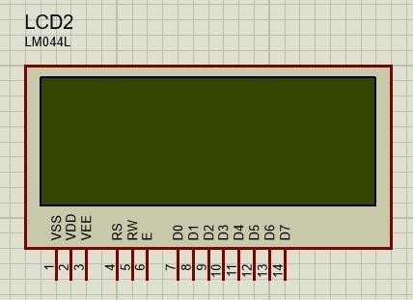

Figure 8: 16x2 LCD Alphanumeric Display

The term LCD stands for liquid crystal display. It is one kind of electronic display module used in an extensive range of applications like various circuits & devices like mobile phones, calculators, computers, TV sets, etc. These displays are mainly preferred for multi-segment light-emitting diodes and seven segments. The main benefits of using this module are inexpensive; simply programmable, animations, and there are no limitations for displaying custom characters, special and even animations etc.
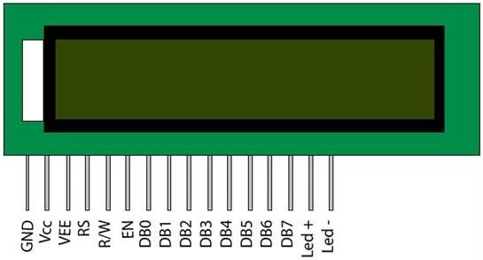
LCD 16×2 Pin Diagram:-

The 16×2 LCD pinout is shown below.
- Pin1 (Ground/Source Pin): This is a GND pin of display, used to connect the GND terminal of the microcontroller unit or power source.
- Pin2 (VCC/Source Pin): This is the voltage supply pin of the display, used to connect the supply pin of the power source.
- Pin3 (V0/VEE/Control Pin): This pin regulates the difference of the display, used to connect a changeable POT that can supply 0 to 5V.
- Pin4 (Register Select/Control Pin): This pin toggles among command or data register, used to connect a microcontroller unit pin and obtains either 0 or 1(0 = data mode, and 1 = command mode).
- Pin5 (Read/Write/Control Pin): This pin toggles the display among the read or writes operation, and it is connected to a microcontroller unit pin to get either 0 or 1 (0 = Write Operation, and 1 = Read Operation).
- Pin 6 (Enable/Control Pin): This pin should be held high to execute Read/Write process, and it is connected to the microcontroller unit & constantly held high.
- Pins 7-14 (Data Pins): These pins are used to send data to the display. These pins are connected in two-wire modes like 4-wire mode and 8-wire mode. In 4-wire mode, only four pins are connected to the microcontroller unit like 0 to 3, whereas in 8-wire mode, 8-pins are connected to microcontroller unit like 0 to 7.
- Pin15 (+ve pin of the LED): This pin is connected to +5V
- Pin 16 (-ve pin of the LED): This pin is connected to GND.

Features of LCD 16x2
The features of this LCD mainly include the following.

- The operating voltage of this LCD is 4.7V-5.3V.
- It includes two rows where each row can produce 16-characters.
- The utilization of current is 1mA with no backlight.
- Every character can be built with a 5×8-pixel box.
- The alphanumeric LCDs alphabets & numbers.
- Is display can work on two modes like 4-bit & 8-bit.
- These are obtainable in Blue & Green Backlight.
- It displays a few custom generated characters.

Power supply or Battery
A power supply is an electrical device that supplies electric power to an electrical load. The main purpose of a power supply is to convert electric current from a source to the correct voltage, current, and frequency to power the load. As a result, power supplies are sometimes referred to as electric power converters. Some power supplies are separate standalone pieces of equipment, while others are built into the load appliances that they power. Examples of the latter include power supplies found in desktop computers and consumer electronics devices. Other functions that power supplies may perform include limiting the current drawn by the load to safe levels, shutting off the current in the event of an electrical fault, power conditioning to prevent electronic noise or voltage surges on the input from reaching the load, power-factor correction, and storing energy so it can continue to power the load in the event of a temporary interruption in the source power.

Battery
It is a device which stores electrical energy.
A battery often consists of one or more “cells” that are electrically connected in either a serial or parallel configuration to provide the required voltage
and current levels.
We normally group them together in a serial arrangement to increase the voltage or in a parallel arrangement to increase current.
The diagram shows these two arrangements.
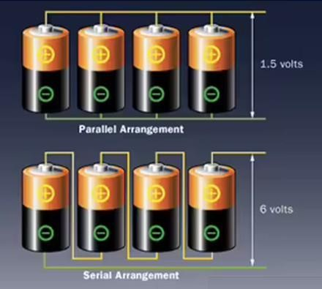

Batteries are rated in amp-hours, or in the case of smaller size household batteries, milliamp-hours (mAH).
Basically, batteries are classified into two types:
- Primary (non-rechargeable)
- Secondary (rechargeable)

The first and the most commonly used rechargeable batteries are Lead – Acid Batteries. The second type of the rechargeable batteries are called Nickel – Cadmium Batteries.

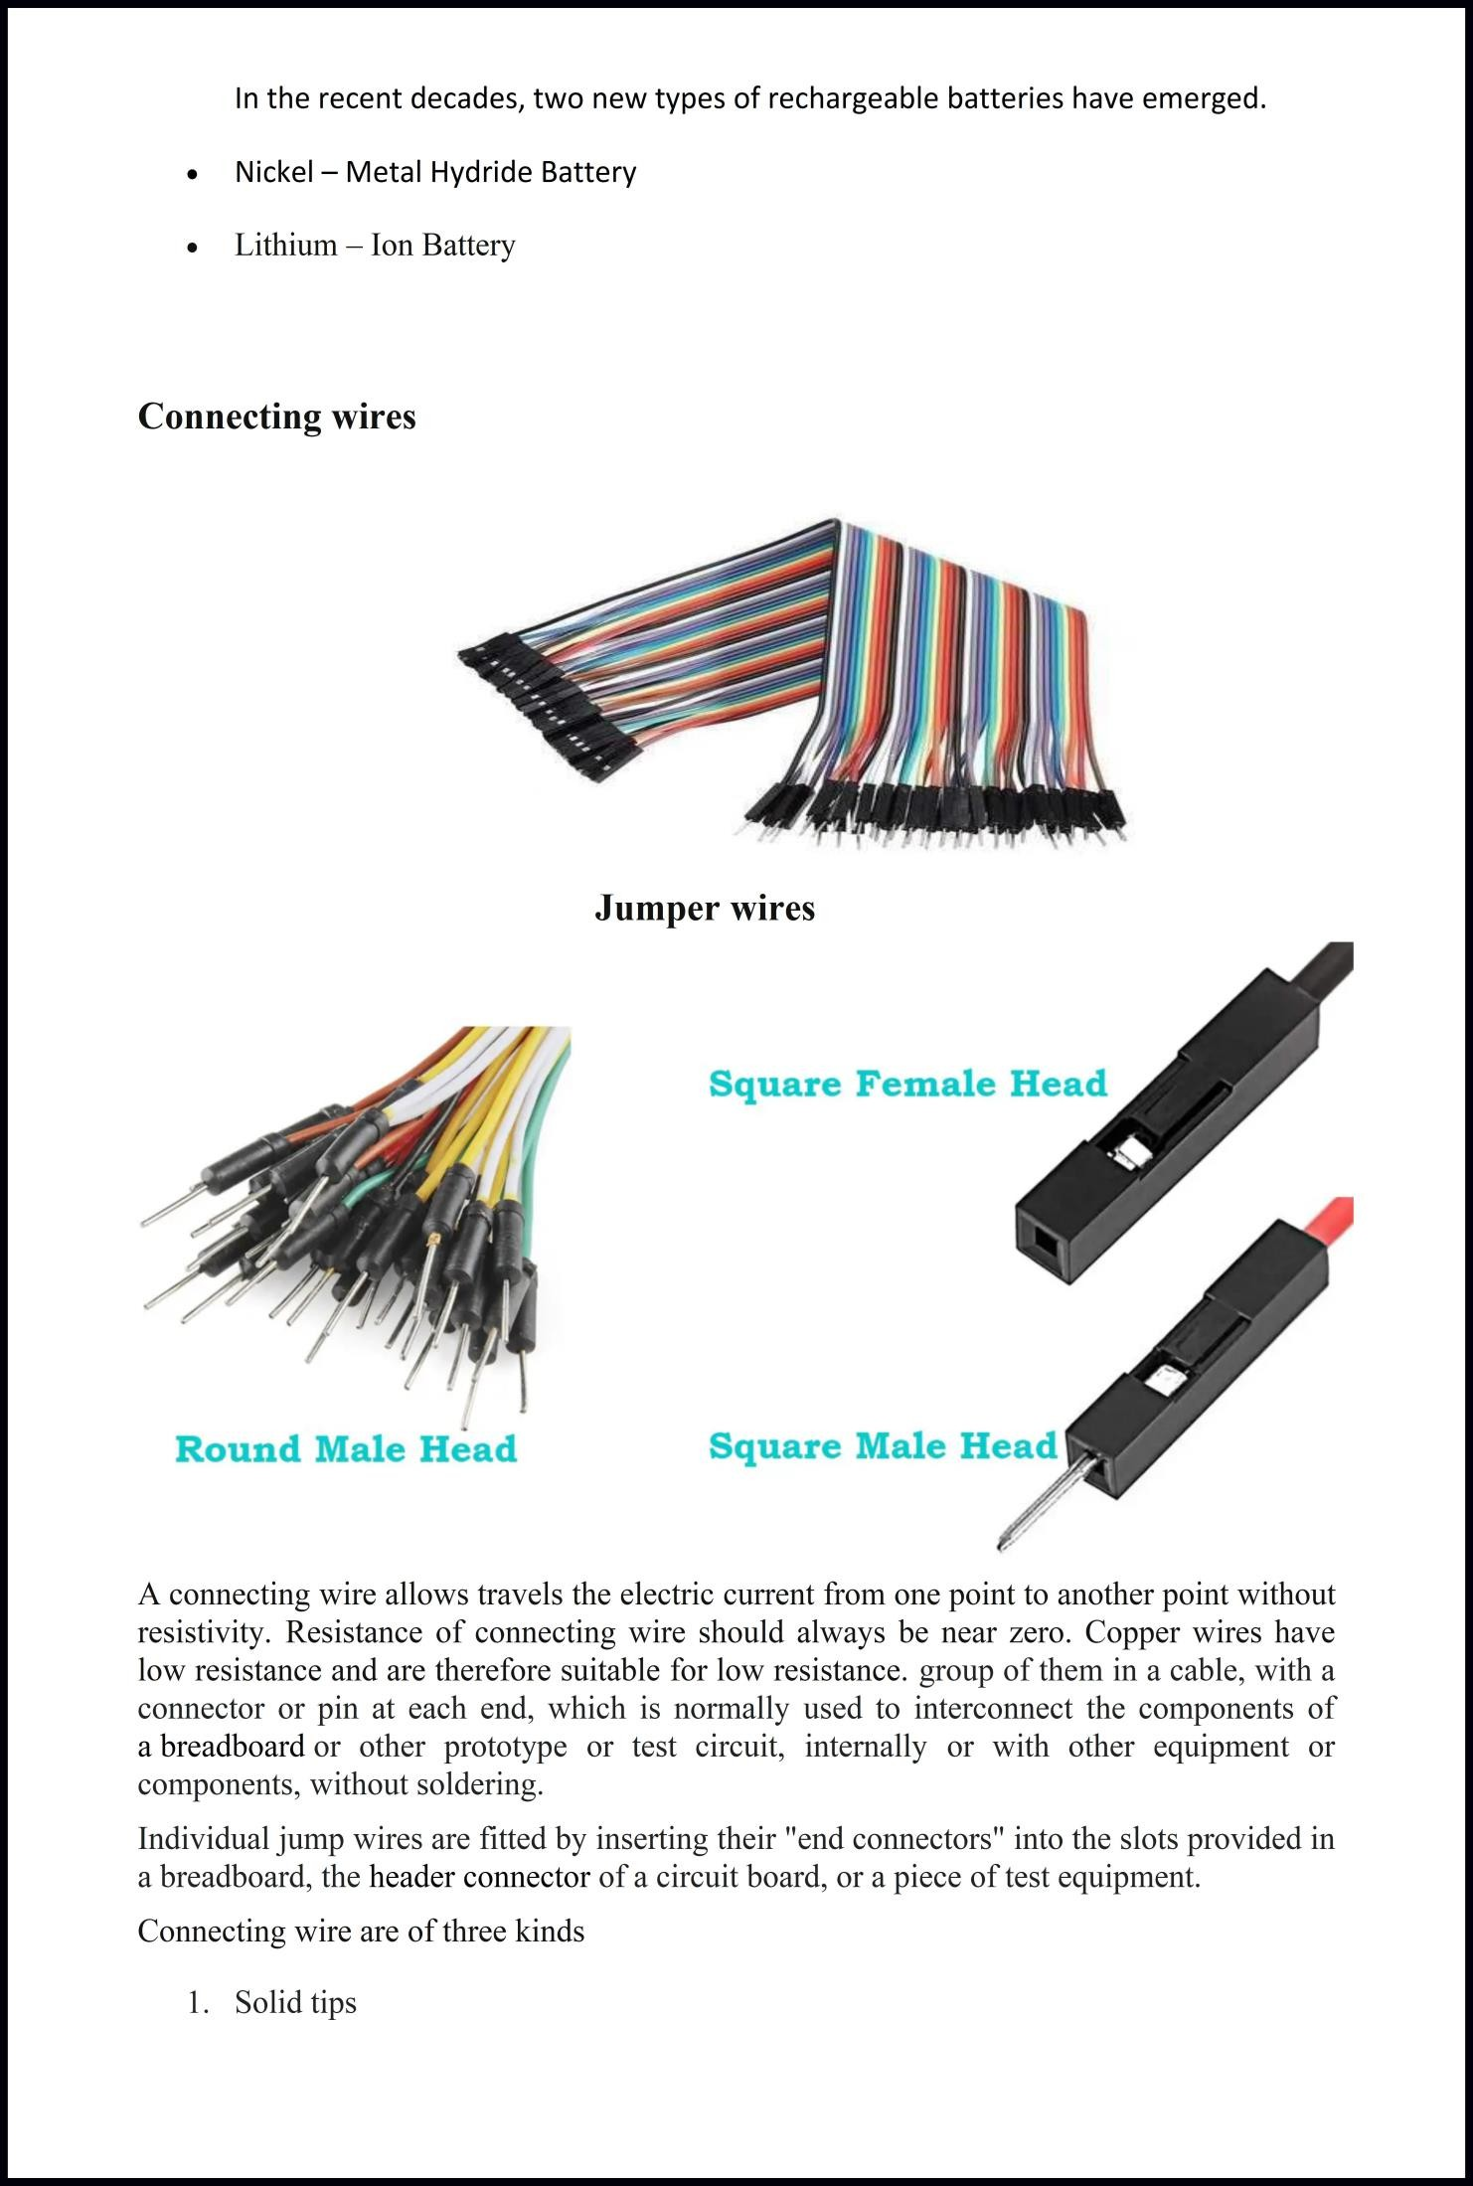

- Crocodile clips
- Banana connectors
- Registered jack
- RCA connectors
- RF connector
- RF jumper cables

Flow Chart
The flowchart represents the complete working process of the Smart Car Parking System using Arduino, IR sensors, and an LCD display. It shows how the system continuously monitors parking slots and updates their status.
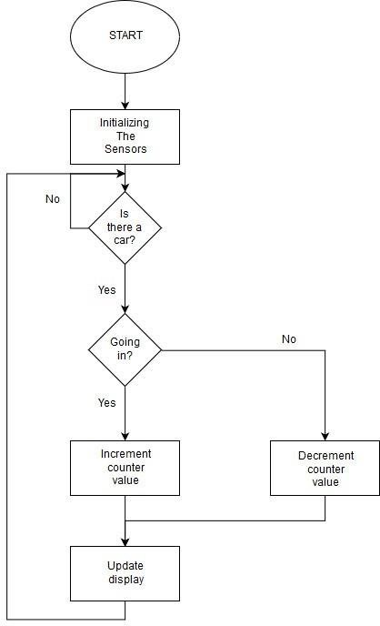

Flow chart of Smart Car Parking System

Flowchart Explanation –
- Start
→ System is powered ON using battery
→ Arduino starts working

Initialize System
→ Initialize Arduino
→ Setup IR sensors, LCD display, and pins

Set Slot Count
→ Total slots = 6
→ Initialize variable: i = 1
→ Initialize count = 0

Read IR Sensors
→ Arduino reads all IR sensors
→ Each sensor represents one parking slot

Check Car Detection
→ If IR output = HIGH → Car present (Occupied)
→ If IR output = LOW → No car (Empty)

Update Slot Status
→ If occupied → count = count + 1
→ Mark slot as OCCUPIED
→ Else → Mark slot as EMPT

Update LCD Display
→ Display slot status (1 to 6)
→ Available slots = Total − Occupied

Increment Counter
→ i = i + 1

Check Condition
→ If i ≤ 6 → Repeat steps for next slot
→ If i > 6 → All slots checked

Repeat Process
→ System runs continuously
→ Updates parking status in real-time

Circuit Diagram and Explanation:

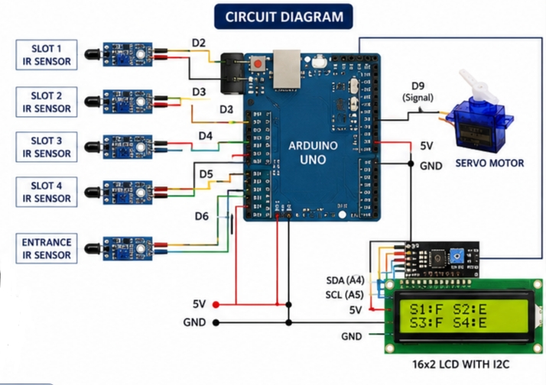
Block diagram of smart car parking system

The circuit shown in Figure an Arduino microcontroller (MCU) requires only 5V. As Arduino Uno has an inbuilt 5V voltage regulator, a common 5V supply can be used for the whole system.

The brain of the circuit is Arduino Uno MCU board (BOARD1). It is based on Arduino UNO R3 V1.0 and has 14 digital input/output (I/O) pins, six analogue inputs, servo motor, a USB connection, IR sensor with 12 C module among others. It can be programmed using

Arduino IDE software IR sensor are connected to Arduino digital pins 2 and 3 and servo motor are connected to Arduino pins 13, which are used for serial communication.
The LCD display (LCD1) is used to display messages during action. Here, a 16×2 display is used; each character is made of 5×7 dot-matrix. Pins 3, 4, 5 and 6 of the LCD are the control lines connected to preset (PR1) output, pin 12 (Arduino), GND and pin 11 (Arduino). Pins 11, 12, 13 and 14 are data pins of the LCD that are connected to pins 7, 6, 5 and 4 of Arduino, respectively. Preset PR1 is used to adjust the contrast of the LCD display.

Construction and working principle:
The project is a sensor based automatic system. The project consists of Arduino Mega microcontroller to which a IR sensor, LCD Display and power supply or cells are interfaced. The input IR sensors reads presence of any car and sends to the controller Arduino UNO board. While entry IR sensor detect car, in condition of having available (1,2,3,4,5,6)slot. The LCD display gets instruction from the board. The LCD displays the parking slots which are empty for the car drivers. While A car gets into a 1 slot, the corresponding slot status in the LCD display shows "PARKING AVAILABLE (2,3,4,5,6) ". At the time of exiting a slot, the status of the slot changed to "PARKING AVAILABLE". When all the slots are booked, the system doesn't allow the seventh car to enter, and shows "PARKING FULL". The IR sensors detect the presence and absence of car in each parking slot.When a car exits from a slot, the IR sensor detects the car and sends to the controller Arduino UNO board. Then total available free slot count increase by 1 in the screen

Code Explanation:

Arduino IDE Platform:
Arduino is composed of two major parts: The Arduino board, which is the piece of hardware to do experiments on; and the Arduino Integrated Development Environment (IDE), the piece of software which runs on computer. We use the IDE to create a sketch (a little computer program) that we upload to the Arduino board. The sketch tells the board exactly what operation to perform.

Arduino-Compiling and Uploading Code

1.Write the code

2. Compile the code

3. Check Arduino Port Connection

4. Upload the Code

5.The Arduino and Connected Circuits start to show behavior based on the uploaded code.

include <Servo.h>

// ---------------- LCD ----------------
LiquidCrystal_I2C lcd(0x27, 16, 2);

// ---------------- Servo ----------------
Servo gateServo;

// ---------------- IR Sensors ----------------
const int slot1 = 2;
const int slot2 = 3;
const int slot3 = 4;
const int slot4 = 5;

// Entrance sensor
const int entranceSensor = 6;

// Exit/Pass sensor after gate
const int gatePassSensor#include <Wire.h>
= 7;

// Servo pin
const int servoPin = 9;

// ---------------- Variables ----------------
int s1, s2, s3, s4;
int totalFilled = 0;#include <LiquidCrystal_I2C.h>

bool gateOpened = false;

// Timing variables
unsigned long lastLCDUpdate = 0;
unsigned long lcdInterval = 500;

// ---------------- SETUP ----------------
void setup()
{
Serial.begin(9600);

Serial.println("=================================");
Serial.println(" SMART CAR PARKING SYSTEM ");
Serial.println("=================================");

// Sensor pins
pinMode(slot1, INPUT_PULLUP);
pinMode(slot2, INPUT_PULLUP);
pinMode(slot3, INPUT_PULLUP);
pinMode(slot4, INPUT_PULLUP);

pinMode(entranceSensor, INPUT_PULLUP);
pinMode(gatePassSensor, INPUT_PULLUP);

// Servo setup
gateServo.attach(servoPin);

// Gate closed initially
closeGate();

// LCD setup
lcd.init();
lcd.backlight();

// ---------------- PROJECT DISPLAY ----------------
lcd.setCursor(0, 0);
lcd.print(" SMART CAR");

lcd.setCursor(0, 1);
lcd.print("PARKING SYSTEM");

delay(2500);

lcd.clear();
lcd.setCursor(0, 0);
lcd.print(" PROJECT DONE");

lcd.setCursor(0, 1);
lcd.print(" BY");

delay(2000);
lcd.clear();

lcd.setCursor(0, 0);
lcd.print(" AKASH R");

delay(2000);
lcd.clear();

lcd.setCursor(0, 0);
lcd.print("DHANANJAYA K M");

delay(2000);
lcd.clear();

lcd.setCursor(0, 0);
lcd.print("DHARANI DHARAN R");

delay(2000);
lcd.clear();

lcd.setCursor(0, 0);
lcd.print(" WELCOME");

delay(2000);
lcd.clear();

Serial.println("System Ready");
}
// ---------------- LOOP ----------------
void loop()
{
// Read parking slots
readSlotSensors();

// Print sensor values
printSensorStatus();
// Update LCD every 500ms
if (millis() - lastLCDUpdate >= lcdInterval)
{

updateLCD();
lastLCDUpdate = millis();
}

// ---------------- PARKING FULL ----------------
if (totalFilled >= 4)
{
closeGate();

Serial.println(" PARKING FULL");

lcd.clear();
lcd.setCursor(0, 0);
lcd.print(" PARKING FULL");

lcd.setCursor(0, 1);
lcd.print(" NO SPACE");

delay(5000);
return;
}

// Detect incoming vehicle
if (digitalRead(entranceSensor) == LOW && !gateOpened)
{

Serial.println("---------------------------------");
Serial.println("Vehicle Detected At Entrance");
Serial.println("Opening Gate");

lcd.clear();
lcd.setCursor(0, 0);
lcd.print("CAR DETECTED");

lcd.setCursor(0, 1);
lcd.print("OPENING GATE");

openGate();

// Wait until car passes through gate
waitForVehicleToPass();

// ---------------- 2 SECOND DELAY ----------------
delay(500);

// Close gate
Serial.println("Closing Gate");

lcd.clear();
lcd.setCursor(0, 0);
lcd.print("CLOSING GATE");

closeGate();

delay(500);
lcd.clear();
}

delay(100);
}

// ======================================================
// FUNCTION: READ SLOT SENSORS
// ======================================================
void readSlotSensors()
{
s1 = digitalRead(slot1);
s2 = digitalRead(slot2);
s3 = digitalRead(slot3);
s4 = digitalRead(slot4);

totalFilled = 0;

if (s1 == LOW) totalFilled++;
if (s2 == LOW) totalFilled++;
if (s3 == LOW) totalFilled++;
if (s4 == LOW) totalFilled++;
}

// ======================================================
// FUNCTION: UPDATE LCD
// ======================================================
void updateLCD()
{
lcd.setCursor(0, 0);

lcd.print("Free Slots:");
lcd.print(4 - totalFilled);
lcd.print(" ");

lcd.setCursor(0, 1);

lcd.print("1:");

if (s1 == LOW)
lcd.print("F ");
else
lcd.print("E ");

lcd.print("2:");

if (s2 == LOW)
lcd.print("F ");
else

lcd.print("E ");
lcd.print("3:");
if (s3 == LOW)
lcd.print("F ");
else

lcd.print("E ");
lcd.print("4:");
if (s4 == LOW)
lcd.print("F");
else

lcd.print("E");
}

// ======================================================
// FUNCTION: SERIAL DEBUG
// ======================================================
void printSensorStatus()
{
Serial.print("S1:");
Serial.print(s1 == LOW ? "FULL " : "EMPTY ");

Serial.print("S2:");
Serial.print(s2 == LOW ? "FULL " : "EMPTY ");

Serial.print("S3:");
Serial.print(s3 == LOW ? "FULL " : "EMPTY ");

Serial.print("S4:");
Serial.print(s4 == LOW ? "FULL " : "EMPTY ");

Serial.print(" | Filled:");
Serial.print(totalFilled);

Serial.print(" | Entrance:");
Serial.print(digitalRead(entranceSensor));

Serial.print(" | Pass:");
Serial.println(digitalRead(gatePassSensor));
}

// ======================================================
// FUNCTION: OPEN GATE
// ======================================================
void openGate()
{
gateServo.write(0);
gateOpened = true;
Serial.println("Gate Opened");
delay(500);
}

// ======================================================
// FUNCTION: CLOSE GATE
// ======================================================
void closeGate()
{
gateServo.write(90);

gateOpened = false;

Serial.println("Gate Closed");
}

// ======================================================
// FUNCTION: WAIT FOR VEHICLE TO PASS
// ======================================================
void waitForVehicleToPass()
{
Serial.println("Waiting For Vehicle To Pass");

unsigned long startTime = millis();

// Wait max 5 seconds
while (millis() - startTime < 5000)
{
if (digitalRead(gatePassSensor) == LOW)
{
Serial.println("Vehicle Passing Gate");

while (digitalRead(gatePassSensor) == LOW)
{
delay(50);
}

Serial.println("Vehicle Crossed");

return;
}

delay(50);
}
Serial.println("Timeout - Closing Gate");
}

Advantages of smart car parking system using

IR sensors with arduino

Efficient Space Utilization
  - Helps drivers find empty slots quickly.
  - Reduces unnecessary searching and optimizes parking space usage.

Saves Time
  - Displays available slots instantly on the LCD.
  - Minimizes time spent looking for parking.

Reduces Traffic Congestion
  - Less vehicle movement inside parking areas.
  - Decreases crowding, especially in malls and offices.

Low Cost Implementation
  - Uses affordable components like:
    - Arduino
    - IR sensors
    - LCD display
  - Suitable for small-scale projects and students.

Simple and Easy to Implement
  - Easy circuit design and programming.
  - Beginner-friendly project for learning embedded systems.

Low Power Consumption
  - Consumes less power compared to large automated systems.
  - Can work with battery supply.

Real-Time Monitoring
  - Continuously updates slot availability.
  - Provides accurate parking status (if sensors work properly).

Expandable Design
  - Can be upgraded by adding:
    - More sensors
    - IoT features
    - Mobile app integration

User-Friendly System
  - LCD display and indicators make it easy to understand.
  - No technical knowledge required for users.
Useful in Many Places
  - Can be applied in:
    - Shopping malls
    - Colleges
    - Offices
    - Apartments

Future Enhancement:

Mobile App Integration
  - Connect the system with a smartphone app (via Bluetooth/Wi-Fi).
  - Users can:
    - Check slot availability remotely
    - Reserve parking slots in advance
IoT & Cloud Connectivity
  - Use modules like ESP8266/ESP32 to connect to the internet.
  - Store parking data on cloud platforms.
  - Enable:
    - Real-time monitoring from anywhere
    - Data analytics (peak hours, usage trends)

Automatic Gate Control
  - Add a servo motor to control entry/exit gates.
  - Gate opens automatically when a slot is available and closes when full.

RFID / Smart Card System
  - Use RFID for:
    - Vehicle identification
    - Automated entry and exit tracking
  - Useful for offices, malls, and apartments.
Camera & Number Plate Recognition
  - Integrate a camera with AI-based number plate recognition.
  - Enhances:
    - Security
    - Automatic billing and tracking
Online Payment System
  - Enable digital payments (UPI, cards).
  - Automatically calculate parking fees based on time.

Advanced Alerts & Notifications
  - Send SMS/notifications when:
    - Parking is full
    - A reserved slot is about to expire
Smart Display System
  - Add larger LED displays at entry points showing:
    - Available slots
    - Direction guidance (left/right/level)
Guided Parking System
  - Use LEDs or arrows to guide drivers to the nearest empty slot.
  - Reduces time and congestion

Solar Power Integration
  - Replace battery with solar panels for eco-friendly operation.

AI-Based Prediction
  - Use machine learning to:
    - Predict parking availability
    - Suggest best time to park

Multi-Level Parking Support
  - Extend the system to handle:
    - Multiple floors
    - Section-wise slot management

DISADVANTAGES :

Limited Accuracy of IR Sensors
  - IR sensors can give incorrect readings due to:
    - Sunlight interference
    - Dust, dirt, or obstacles
  - This may lead to wrong slot status (occupied/empty).

Wiring Complexity
  - As the number of parking slots increases, wiring becomes:
    - Messy
    - Difficult to manage and maintain

Limited Scalability
  - Using an Arduino UNO limits:
    - Number of input pins
    - Ability to handle large parking areas
Not ideal for multi-level or large parking systems.

Power Dependency
  - System depends on continuous power supply.
  - Battery backup may not last long for large setups.
Maintenance Issues
  - Sensors require regular cleaning and calibration.
  - Faulty sensors can affect the entire system’s accuracy

No Remote Access (Basic Version)
  - Without IoT integration:
    - Users cannot check availability remotely
    - System works only locally

No Vehicle Identification
  - System only detects presence of a car, not:
    - Vehicle type
    - Owner identity
  - Cannot prevent unauthorized parking.

Cost Increases with Scale
  - More slots → more sensors, wiring, components
  - Cost rises significantly for large implementations.

Response Delay (Small)
  - Slight delay in updating slot status due to:
    - Processing time
    - Sensor detection lag

Basic Security
  - No built-in security features like:
    - Surveillance
    - Access control
  - Not suitable for high-security areas without upgrades.

Conclusion:
The Smart Car Parking System using Arduino and IR sensors is an efficient and practical solution to manage parking spaces in an organized manner. It successfully demonstrates how embedded systems can be used to monitor real-time parking availability and reduce the time and effort required to find a parking slot.
By using IR sensors for detection and an LCD display for output, the system provides accurate and user-friendly information about vacant and occupied spaces. The project is cost-effective, easy to implement, and suitable for small-scale applications such as colleges, offices, and residential areas.However, it also highlights certain limitations like sensor accuracy and scalability, which can be improved with advanced technologies such as IoT, mobile applications, and automated control systems.
Overall, this project serves as a strong foundation for developing smarter, more efficient parking solutions in the future and showcases the potential of automation in solving real-world problems.This project provides a cost-effective, sustainable, and reliable solution for urban parking issues. Future enhancements can include IoT for remote monitoring via smartphone applications.
Arduino is a microcontroller-based platform used for rapid prototyping. Arduino is a starter package for beginners and designed for students to get into the programming world however Arduino is not designed for a harsh industrial environment. Arduino has limited processing power that cannot meet industrial requirements. If you must design a complex project that demands rapid and high processing ability, then a microprocessor board like Raspberry Pi is the best choice which has a lot more functionality.
All students all over the world can make experiments with Arduino codes using different materials, one of those is smart car parking system using ir-sensor. Arduino makes it more interesting and interactive as it is used daily life.

Reference links
https://www.arduino.cc/en/Main/ArduinoBoardMega. https://www.engineersgarage.com/electronic-components/16x2-lcd-module-datasheet .
https://www.watelectronics.com/ir-sensor.

